May | RA 029A Full Opening of school v10 1st April 2022 | RISK ASSESSMENT  RECORDING FORM

Location or School  Address: HILBRE HIGH SCHOOL | Date assessment  Undertaken: 1/4/2022 | Assessment undertaken by: Jeanne Fairbrother & J Doyle- SBM
Activity or situation:  Full Opening of school v10 1st April 2022 | Review  date: Weekly review or as appropriate for the activity | Signature: J Doyle

Background information

From 1 April, the government's guidance on living with COVID-19 replaces the DfE's operational guidance for schools.

Please note that this risk assessment has been created in line with the current guidance. It contains sample control measures that fit with the latest guidance. One size does not fit all, and schools should make this model risk assessment their own and reflect any local measures, particularly local HPT’s guidance.

See [UPDATE] sections.

This applies to all schools, early years settings and FE Colleges.

Legislation and guidance
Health and Safety at Work Act etc. 1974
Management of H&S at Work Regulations 1999
Workplace (Health, Safety and Welfare) Regulations 1992
N.B. All risk assessments referred to within this document have been revised and are available on our website www.jeannefairbrotherassociates.com

1) Hazard / Activity | 2) Who can be harmed and how? | 3) What controls exist to reduce the risk?  Have you followed the hierarchy of controls (eliminate, substitute etc)? | Risk Score  Consequence  X Likelihood | 4) Any further action.  This should be included in the action plan (5), below
UPDATED Failing to have adequate outbreak management/contingency plans to allow for stepping measures up and down.  All settings unless indicated | Staff, pupils, visitors, contractors increased risk of transmission of COVID 19 | - School has a Coronavirus (COVID-19) Contingency Plan risk assessment. See RA 029B Contingency plan latest version (also known as an outbreak management plan) if restrictions need to be implemented due to COVID 19 variants outbreak.  - School will only:  - Consider attendance restrictions as a last resort  - Keep measures to the minimum number of groups possible  - Keep measures for the shortest amount of time possible  - School will take extra steps to manage the transmission of COVID-19 and seek public health advice if the number of positive cases reaches a certain threshold.  - School will follow measures recommended by the Local Authority, Director of Public Health and local protection teams (HPTs) as part of the outbreak management responsibilities.  - School has updated its School Emergency Plan in line with April 1st DfE guidance : Emergency planning and response for education, childcare, and children’s social care settings which includes public health emergencies .  - School will refer to UK Health Security Agency (UKHSA) health protection in education and childcare settings  - Insert details of school’s local PH Helpline phone number to contact i.e.  - Cheshire & Merseyside PHE contact 0344 225 0562 | 3X2=6 | School will react to any outbreaks in line with Public health advice. Plans in place
UPDATE Face coverings  All settings unless indicated | Staff, pupils, visitors, contractors increased risk of transmission of COVID 19 | All settings unless indicated  - All settings - Face coverings are no longer advised for pupils, staff and visitors in classrooms or communal areas.  - Staff and pupils should follow wider advice on face coverings outside of school, including on transport to and from school.  - School may be advised by a director of public health that face coverings should temporarily be worn in communal areas or classrooms (by pupils, staff and visitors, unless exempt). School has contingency plans that cover this possibility.  - All settings – any staff who wish to wear a face covering in school will be supported to do so. | 3X2=6 | All staff, students, parents, guardians have been advised of this change
UPDATE School fails to ensure good hygiene & cleaning standards in school to reduce risk of transmission.  All settings unless indicated | Staff, pupils, visitors, contractors increased risk of transmission of COVID 19 | Hand hygiene -  - School will continue to ensure that staff & pupils maintain high standards of hand hygiene.  - Suitable facilities are provided for individuals to wash/sanitise their hands regularly  Cleaning  - School will maintain appropriate cleaning regimes, using standard products such as detergents with a focus on frequently touched areas. | 3X2 | Cleaning regimes in place managed by SPIE
UPDATED Events in school  All settings unless indicated | Staff, pupils, visitors, contractors increased risk of transmission of COVID 19 | - School completes a separate risk assessment for any events held in school following the latest UKHSA guidance | 3X2=6 | Any planned events will be suitable managed and Risk Assessed.
UPDATED Ventilation - failure to ensure all occupied spaces are well ventilated.  All settings unless indicated | Staff, pupils, visitors, contractors increased risk of transmission of COVID 19 | - When school is in operation, it is well ventilated with comfortable teaching environments.  - Poorly ventilated spaces have been identified [insert details of any areas here plus control measures in place to improve them] | 3X2=6 | Staff advised to continue to keep windows open in classrooms
UPDATED Close contacts  All settings unless indicated | Staff, pupils, visitors, contractors increased risk of transmission of COVID 19 | All settings  - From 24 February, routine contact tracing will end. Contacts will no longer be required to self-isolate or advised to take daily tests.  - Local health teams continue to use contact tracing and provide context-specific advice where they assess this to be necessary as part of their role in managing infectious  diseases.  - Staff or pupils who are close contacts should:  - avoid contact with anyone who is at higher risk of becoming severely unwell if they are infected with COVID-19, especially those whose immune system means they are at higher risk of serious illness from COVID-19, despite vaccination  - limit close contact with other people especially in crowded, enclosed or poorly ventilated spaces  - wear a well-fitting face covering made with multiple layers or a surgical face mask if you do need to have close contact with other people, or you are in a crowded place  - wash hands frequently with soap and water or use hand sanitiser | 3X2=6  Review this score as the more measures in place will reduce it. | Staff have been advised that they no longer need to remain at home , unless they have need to take a test for a specific reason and the result is positive.  If they show symptoms of a fever, sire throat, cough but are not positive, they can remain at home as sickness absence.
UPDATED Positive case unaware of new guidance  All settings unless indicated | Staff, pupils, visitors, contractors increased risk of transmission of COVID 19 | All settings  - Those with a positive test result will be advised to try to stay at home and avoid contact with other people:  - Staff for 5 days  - Pupils for 3 days  - Both pupils and staff should try to stay home and avoid contact with others if they have symptoms of a respiratory infection and a high temperature or if they feel unwell (returning to school when they feel well enough, and no longer have a high temperature) | 3X2=6
UPDATE Asymptomatic testing  All settings unless indicated | Staff, pupils, visitors, contractors increased risk of transmission of COVID 19 | All settings  - Staff and students in all education and childcare settings are no longer required to carry out twice weekly asymptomatic testing.  - Free testing no longer available for schools and no longer advised in specialist settings  - If there's an outbreak in school, local directors of public health might advise testing for staff, and for pupils of secondary age and above, for a period of time  - Spare tests should be kept and only used if advised by your local health protection team, local authority or director of public health”. | 3X2=6
People at higher risk of becoming seriously unwell from a respiratory infection, including COVID-19  - older people  - those who are pregnant  - those who are unvaccinated  - people of any age whose immune system means they are at higher risk of serious illness  - people of any age with certain long-term conditions  All settings unless indicated | Staff, pupils, visitors, contractors increased risk of transmission of COVID 19 | All settings  - School is aware that certain staff and pupils may be at higher risk becoming seriously unwell from respiratory infections.  - People in this category are advised to follow Living safely with respiratory infections including Covid 19  - School will discuss any concerns with employees and parents/carers. And this may form the basis of a personal risk assessment.  - Employees who have received personal advice from their specialist or clinician on additional precautions to take should continue to follow that advice and advise school. | 3X2=6 | Expectant mothers will have an individual Risk Assessment completed for them and re3viewed regularly.  Previous advice has now been withdrawn from Gov.uk site and has been replaced by Living Safely with respiratory infections.

Risk Rating | Action Required
20 - 25 | Unacceptable – stop activity and make immediate improvements
10 - 16 | Urgent action – take immediate action and stop activity, if necessary, maintain existing controls vigorously
5 - 9 | Action – Improve within specific timescales
3 - 4 | Monitor – but look to improve at review or if there is a significant change
1 - 2 | Acceptable – no further action but ensure controls are maintained & reviewed
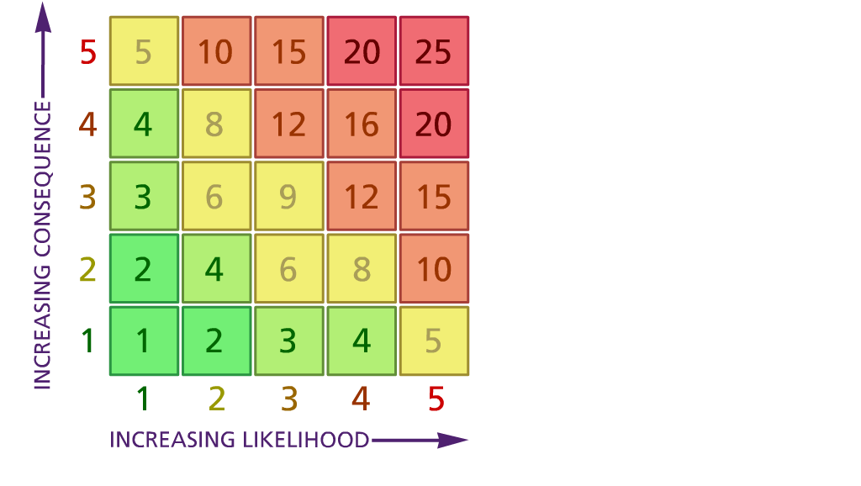

Likelihood: Consequence:
(1) List hazards something with the potential to cause harm here
(2) List groups of people who are especially at risk from the significant hazards which you have identified
- List existing controls here or note where the information may be found. Then try to quantify the level of risk the likelihood of harm arising that remains when the existing controls are in place based on the number of persons affected, how often they are exposed to the hazard and the severity of any consequence. Use this column to list the controls that you might take and develop all or some of that list into a workable action plan. Have regard for the level of risk, the cost of any action and the benefit you expect to gain. Agree the action plan with your team leader and make a note of it overleaf. If it is agreed that no further action is to be taken this too should be noted.

5 – Very likely 5 – Catastrophic

4 – Likely 4 – Major
3 – Fairly likely 3 – Moderate

2 – Unlikely 2 – Minor

1 – Very unlikely 1 – Insignificant

(5) ACTION PLAN
 |  | Responsible | Completed
1 | Circulate the final version to all staff & stakeholders | HT
2
3
4
5
6
7
8
9
10
 | Action plan agreed by (NAME & DATE)

